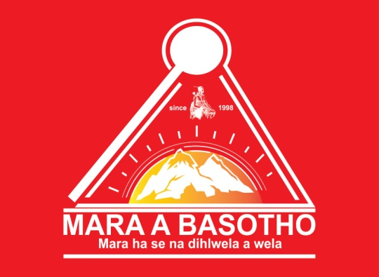

MARA A BASOTHO
MEMBERSHIP APPLICATION FORM – 2023 LESOTHO BRANCH

Name and Surname
ID No
Cellphone No
Street Address
City, Town, Province
Gender & Age
Employed | Yes/No(circlewhicheverisapplicable)
Student | Yes/No(circlewhicheverisapplicable)
Highest Education Level
(No schooling, Primary School, High School, Degree, Honors, Masters, Doctorate)
Sesotho Proficiency
(Read, write, speak/ fluent, poor, none)
Relatives in South Africa | Yes/No(circlewhicheverisapplicable)
Relatives in Lesotho | Yes/No(circlewhicheverisapplicable)
Clan name (Seboko)  (e.g. Mohlakoana, Motaungwa ha Hlalele, etc) | wa ha
Been a Mara Member Since
(e.g. 1998)

Bank Details: FNB Gold Business Account: 63000042985
Universal Branch Code: 250655
Account Holder: Mara a Basotho NPC

